Analysis Me

Analysis Me
Technical Report
Fall
2016
Team IoT-Q
Enclosed in this document is the technical report of the project titled ‘Fog mediated data sharing for IoT platforms’ sponsored by CMU.

Table of Contents
Introduction 3
Motivation 3
Related Work 5
System Design 5
Fog computing 5
Privacy-preserving machine learning 7
System Implementation 9
Fog computing 9
Privacy-preserving machine learning 10
Query processing and substitution 10
Experiments and Analysis 11
1 Layer: Adversary only 12
1 Layer: Adversary + Defender 12
2 Layers: Adversary only 13
2 Layers: Adversary + Defender 14
Conclusions and Future Work 15
References 16

- Introduction
The primary goal of this project is to build a fog mediated data-sharing platform without compromising on either the user’s privacy or the accuracy of the action on the data being sensed and shared. Simply stated, the idea is to implement a data-sharing platform that utilizes sensed data to produce useful actions on them, while preserving the user’s privacy simultaneously. Specifically, the goal is to deploy the proposed data-sharing service on the Qarnot computing platform and, if possible, use the data collected from Qarnot smart home terminal devices to evaluate the solution’s accuracy and performance.

- Motivation
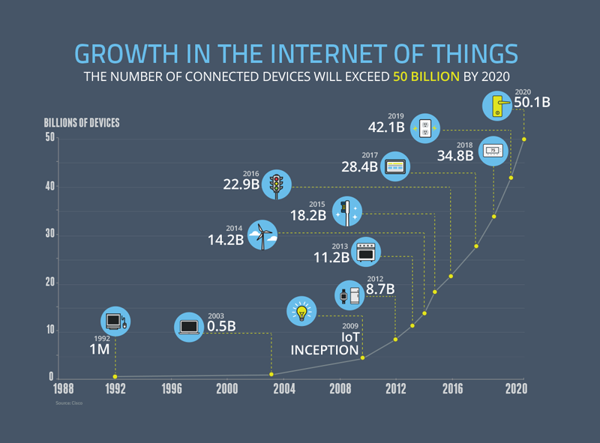
The Internet of Things (IoT) has become increasingly ubiquitous during the past few years with the advent of ideas such as Smart Home, Smart Energy Grids, wearables and personal sensing devices, etc. Cisco has predicted that there will be over 50 billion such connected devices by 2020, as shown in the below chart.

Most of these ‘things’ or IoT devices sense, measure, collect and act upon data for a specific application that they are designed for - such as ambient temperature control, vital health monitoring, environmental sensing, etc. Some of these applications deal with critical and sensitive information of a user, home, community or even a city. With deeper and deeper integration of these devices into the user’s environment, there is also a growing concern over the privacy of the data that is being collected or acted upon. Quite often, the data is also shared with other devices/things in the network, and frequently sent
for analysis and computation to a remote server in the cloud domain. The software on these remote servers processes the data and provides the smart devices with results that specify how they can act on the given data.

There are 3 aspects of current IoT systems that are the motivating factors for this project:
- Privacy of sensed/user data
Usually, the data collected by the smart devices is highly sensitive and often user-specific information. This could include things like number of people in a room, patient health monitoring, environmental data, etc. Sharing this data with a remote server leads to possible violation of the user’s privacy. If the data is compromised by anyone along the transmission channel, it enables them to easily identify the user with whom it is associated.

- Meaningful results and actions on sensed data
One of the critical functions of IoT systems is not only data collection, but acting on the sensed data. Quite often, participants in an IoT system may interact and share their information to collectively produce better results. Data obfuscation and encryption may be a possible way to guarantee user privacy. But it also prevents sharing of sensed data between different nodes in the system. Concealing any useful information that is part of the sensed data may prevent the system from providing useful results.

- Quicker inferences and responses by sensors
Since IoT systems are useful for critical and time-sensitive applications - such as health monitoring, automated vehicular systems, etc - it is important for them to generate inferences and responses in a timely manner. Transmission of data to a remote server for computation and processing hinders this aspect of the system and adds to the network overhead. In this regard, cloud computing is not a viable solution for such applications.

Based on the above reasoning, we can see that there is a need for a method of sharing sensed data between different nodes in the IoT system that preserves privacy of the data and provides quicker and accurate inferences from the data. The proposed solution is to use the ideas of fog computing and privacy-preserving machine learning. Fog computing addresses the problems of network overhead and remote computation that exist in the cloud computing paradigm and enables sharing of data between participants in the system in a transparent and effective manner. Privacy-preserving machine learning models help deduce results from collected data using deep learning, while ensuring that the presence of an adversary in the system does not compromise the privacy of the user data.
- Related Work
Deep learning is a multi-layer network which has been proved to outperform the traditional machine learning techniques. It can analyze complex training data which, in most applications, is sensitive user information that needs to be protected. Secure multiparty communication is a technique in which multiple parties collaborate and run machine learning algorithms on their proprietary training data instead of a single centralized system containing all the training data. Output from the intermediate layers is shared with other parties to build the machine learning model. However, it was proven that this results in high runtime overheads and cannot be applied to large and complex training datasets which need computationally intensive models.

Privacy preserving deep learning technique deal with sharing gradients of chosen parameters in the model with a centralized trusted system and utilizing gradients provided from other parties to train the local model. The disadvantage with this model is that gradient sharing leads to indirect information leakage. It is a trust-based paradigm in which there is a central trusted server - compromising the server would mean compromising the whole system.

Differential privacy is another privacy preserving technique which is quite popular. But the previous work on this does not address the problem of collaborative deep learning with multiple participants using distributed stochastic gradient descent [6].

The goal of a machine learning model is to minimize the overall estimation loss. None of the previously mentioned models account for the loss parameter of the adversary model. If an adversary smartly crafts his model, it would not be hard to retrieve the original data as the loss will always be minimized. In our model, we take this into account and add the negative loss of the adversary to the loss of the original model making it very hard for the adversary to retrieve the input data.

- System Design

- Fog computing
Fog computing is an architecture that enables computing, networking and storage activities to be performed at the edge of the network. This enables the system to provide quality results on collected data, share data between nodes in a quicker manner and minimize the network load and overhead.

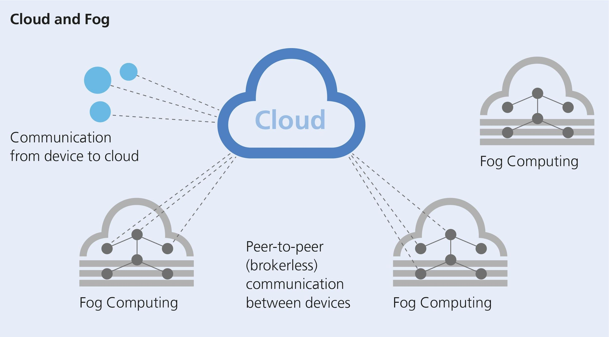
As shown in the adjacent diagram, the fog computing model allows devices that are in proximity to the sensing environment or user to interact with one another through fog domains. The need for remote computation and transmission with the cloud is greatly minimized, allowing for quicker action on sensed data for real-time and critical applications.

In our solution, as stated earlier, we use the fog computing paradigm to enable edge devices/sensors to provide inferences and actions on the collected data in a timely manner so that the utility of the application is enhanced (especially for critical applications).

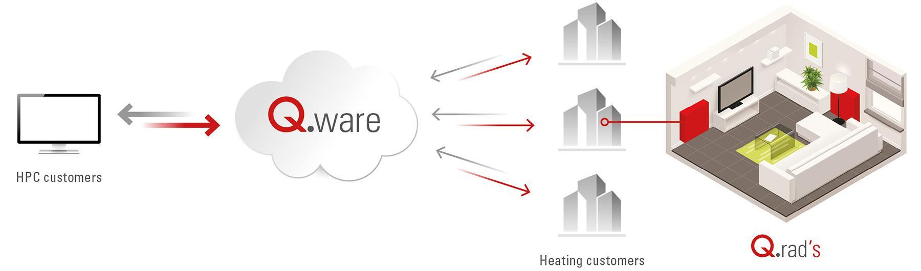
For this project, we have chosen to use the Qarnot computing platform for deploying the fog based data sharing service. Qarnot computing is a real-world fog computing service. It is a distributed high-performance computing service that utilizes heaters (called Q.rad’s) with embedded microprocessors to perform computation and provide free heating to the homes and offices that they are installed in. The diagram below shows the Qarnot platform architecture.

Using the API provided by Qarnot, we can run different kinds of tasks on each of these Q.rad’s. Further, each Q.rad is equipped with a few sensors that can aid in our data collection and training our machine learning model.

In our solution, we propose to deploy customized Docker images (on each Q.rad) that will run the data sharing service. Orchestration of the different nodes (i.e. Q.rad’s) is done using custom API provided by Qarnot. Each node will run a service that allows it to communicate with other nodes running the same Docker image, and simultaneously run the data collection and machine learning models

on the data collected from the Q.rad’s inbuilt sensors. This setup is a good modeling of the actual fog computing scenario that we have discussed in the problem statement.

- Privacy-preserving machine learning
The goal of privacy-preserving machine learning is to build a model that can be trained to produce results with relatively high accuracy, while simultaneously preventing the adversary from restoring the raw/input data from the intermediate result. We propose to do this by training the model in two parts – locally and in the cloud. This means that the different layers of our deep learning neural network will be split across the device (fog node) as well as the remote server (cloud). This ensures that if some of the layers are compromised, the privacy of the entire data is not violated.

The idea of an adversary, who can obtain the intermediate output from any of the layers of our training model, is introduced by adding a simultaneous training model that tries to reverse the intermediate output to obtain the original data. To defend against such an adversary, we introduce certain parameters in our training model that counter the improvement in the accuracy of the adversary’s training model, thus improving the privacy preserving aspect of our overall model.

Thus, the complete privacy-preserving machine learning model is a combination of the traditional machine learning model that tries to produce the best result (inference), an adversary who tries to obtain the input data using the output of any of the intermediate layers of our training model, and a ‘defender’ that attempts to decrease the accuracy of the adversary’s training model and prevent them from reversing intermediate data successfully.

The diagram below represents our privacy-preserving machine learning model:
θ₁
X
local
cloud
Z
Y’
Attacker
Z
X’
θ₂
θ_{1b}
θ_{1a}

The green box represents our training model that uses input data to generate some inferences (based on the application). The red box represents the adversary (who can obtain intermediate output from our model) training model that tries to reverse the intermediate output to obtain the actual input.

Below is the summary of the various components of the model:
- x: Input data
- y: Expected output (label)
- y’: Actual output of the model
- z: Output of intermediate layer of the model
- x’: Output of adversary’s reversal model
- ⎝₁: Parameters describing our training model
- ⎝_{1a}: Parameters describing the layers trained locally
- ⎝_{1b}: Parameters describing the layers trained in the cloud
- ⎝₂: Parameters describing the adversary’s reversal model

In this design, we aim to minimize the losses for each of the specified training models and parameters as follows (L: Loss function for the model):

- L₁ = L (y, y’; ⎝₁): Measures accuracy of our training model
- L₂ = L (x, x’; ⎝₂): Measure of adversary’s success in reversing to obtain raw data from the intermediate data
- L₃ = -L (x, x’; ⎝_{1a}): Measure defender’s (our model’s) ability to prevent the adversary from successfully reversing the intermediate data
- L = L₁ + L₂ + L₃: Overall loss function for the privacy-preserving model

The notion of defending against the adversary, who can obtain intermediate data, is provided by adding a loss function that counters the improvement in accuracy of the adversary’s training model (reversal model).

- System Implementation
To implement this solution, we first need an application that mimics real world IoT data sensing and inferencing. For our project, we considered two applications:

- Image classification which can be extended to ideas such as fall detection, infant monitoring, video surveillance, etc.
- Query processing and substitution using voice sensor data - Due to the challenges associated with parsing, training and decoding audio data, we were unable to scale the speech/query processing implementation for our training model (implementation discussed in this section).

The implementation can be split into the following parts based on the proposed design.

- Fog computing
A custom Docker image was created with the packages, tools and libraries necessary for executing machine learning tasks on individual fog nodes. The tasks to run the Docker images were executed using the publicly available Qarnot SDK.
For node orchestration and data sharing, we require SSH access to the nodes as well custom API to individually control the nodes. As this was not available to us during the project, implementation of the full-fledged data sharing service between the fog nodes was put on hold.

- Privacy-preserving machine learning
The machine learning/deep learning models are implemented in Python using Google’s open source machine learning library TensorFlow. Two image classification datasets were used (for 2 different models):
- MNIST – Handwritten digit recognition and classification
- SVHN – Street View House Numbers classification
The various neural network parameters to define in our model are:
- Parameters for each layer – Weights and Biases
- Loss function – Cross entropy for overall model, root mean square error for the adversary model
- Optimizer – MNIST: Adam optimizer, SVHN: GradientDescentOptimizer

The process of training our privacy-preserving model can be summarized using the diagram on the right. The basic idea is to feed a large training dataset which contains the input images and the expected output (labels). The model learns the classification process using this data. Then, we provide different kinds of test data for which we estimate the model’s accuracy in predicting the right result. The end goal is to maximize the accuracy of the overall model that consists of the adversary and defender models as well.
Run training process in several iterations (epoch)
Feed training data to model in each iteration
Test model performance using test data

- Query processing and substitution
The idea behind this application is to improve privacy of voice data associated with the user. Many smart devices such as smartphones, Google Home, etc. respond to voice commands and make smart decisions using the data collected over time. In this approach, we add many queries to the original query and send them all to the remote server (for processing) so that it is hard for an adversary to pick out the exact query that the user made.

To do this, we use audio input files that represent user’s voice queries. The audio input files are converted into text using the CMU-Sphinx speech-to-text parser which uses hidden markov model. The parsed text is then passed to the CoreNLP library which performs various operations like tokenization, lemmatization, identifying parts of speech, named entity recognition, coreference resolution, sentiment analysis and creating a parse tree. Then, this information is used to create multiple queries, all of which are almost the same as the original query but with slight modifications. The nouns in the user query are replaced by random selection of related nouns from the dataset we have prepared. These queries are then processed at the remote server and the received responses are filtered to only obtain the result that pertains to the actual query. The diagram below shows the entire process:
Input
.wav
Speech-Text
CMU-Sphinx
Natural Language Processing
Core-NLP
Create additional Queries
Send Queries to the Server
Filter Results for User Query Result
Output

The idea was to deploy this on Qarnot platform (fog computing platform) and run experiments to evaluate the scalability of the model. However, we were not able to perform any experiments due to the unavailability of custom API from Qarnot.

- Experiments and Analysis
Several experiments were conducted for the proposed privacy-preserving machine learning algorithm. The goals of these experiments were:
1. Prove our assumption that an adversary can restore the raw data from intermediate output and that the defender can defend against this adversary
2. Find out elements that can affect the performance of adversary and defender.
For the experiments, we have used MNIST dataset (http://yann.lecun.com/exdb/mnist/) as our test dataset. It is an image dataset for handwritten digits’ classification, which contains 55,000 images as training data, 10,000 images as test data, and 5,000 images as validation data. Our machine learning algorithm read image data from the input dataset and the output is the result of a digit classification (digits from 0 to 9).

Our algorithm is run for 30 epochs, and each epoch uses the entire training dataset for the training process. After each epoch, the following parameters were calculated and recorded: test accuracy, validation accuracy and the adversary’s cost. 4 experiments with the following differences in configuration were executed:
1. Output of 1 layer vs Output of 2 layers
2. Adversary only vs adversary + defender

We have evaluated our model performance based on test accuracy and the cost of the adversary.

- 1 Layer - Adversary Only
In the first experiment, the adversary was given the output of the first layer, and there was no defender. Following is the change in test accuracy and cost of adversary as the epoch number increases:
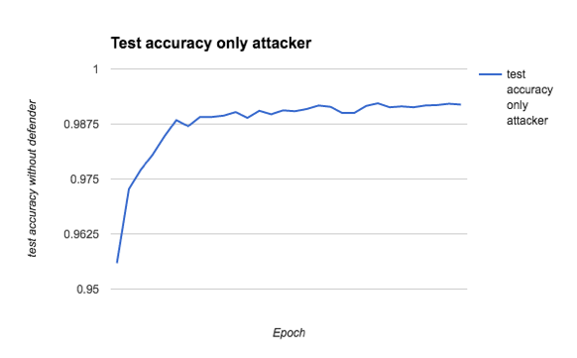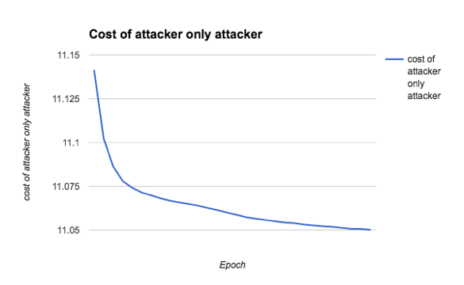
From the graph, we can see that the test accuracy kept increasing as epoch increased, reaching about 99.1% towards the end. However, the cost of the adversary kept decreasing, from 11.14 to about 11.05. Since 99.2% is known to be the best performance of our current model [9], we can see that the presence of adversary will not decrease the performance of the original model. From the second graph, we can also see that the adversary can decrease their cost through iterative training, which means that the adversary can potentially restore the raw data.

- 1 Layer - Adversary + Defender
In the second experiment, we provided the adversary with the output of the first layer, but this time a defender was included. We have run the experiment for 30 epochs, and the result is as follows:

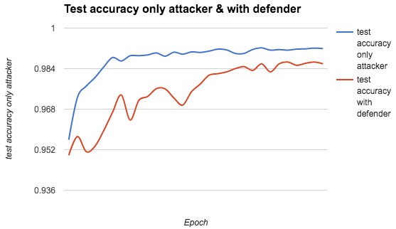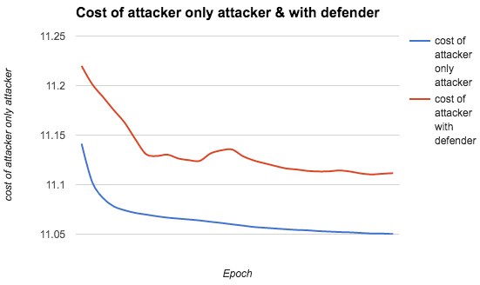
From the left graph, we can see that adding a defender will decrease the test accuracy to a certain extent, from previous 99.1% (blue line) to about 98.5% (red line). We consider this as a tradeoff between the performance and the security of the original model. From the right graph, we can observe that when defender is present, the cost of the adversary is higher (red line) than the case when there’s adversary only (blue line), which can prove that the defender can increase the cost of adversary and thus potentially protect our raw data from being restored.

- 2 Layers - Adversary Only
In the third experiment, we have changed our input data to the adversary. Rather than using the first layer output, we used the second layer output as the input to the adversary. Through this experiment we wished to analyze how the adversary’s performance changes when we feed the adversary more abstract data (the more the number of layers before the intermediate output, the more abstract the data will be).
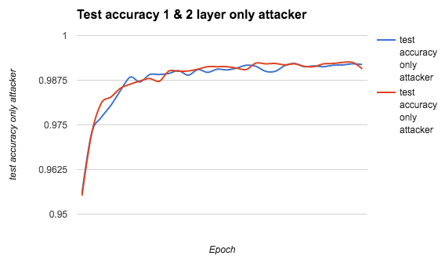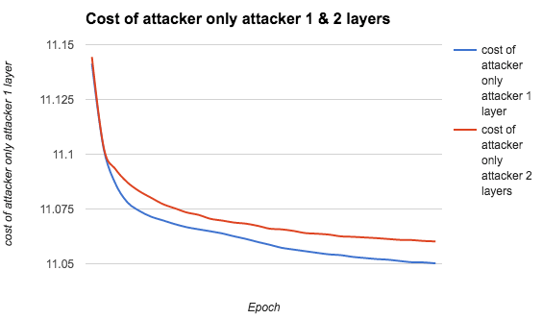
The result above shows that when using the 2-layer output as the input for adversary, the test accuracy will not be affected a lot. However, even though the cost of the adversary kept decreasing, it is higher (red line) than the 1 layer case (blue line) when only adversary is present. It shows that using the output of more layers (or making the input data more abstract) might also be helpful when defend against adversary.

- 2 Layers - Adversary + Defender
Our last experiment used the output of the second layer as input for the adversary, and includes the defender to defend against adversary. From the previous experiments, we can see that adding a defender and using the output of two layers can both increase the cost of adversary. We wish to check whether adding them both will make the defender stronger.
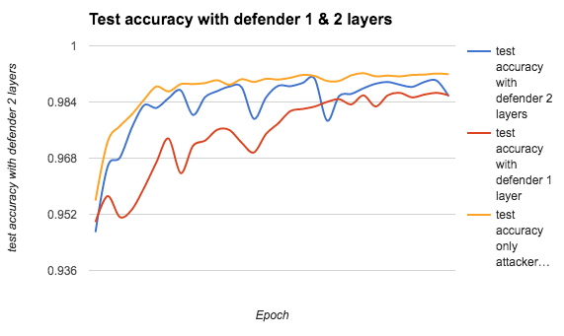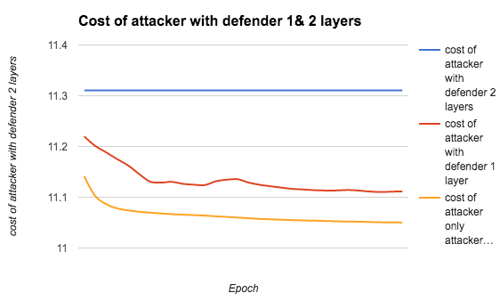
From the left graph, it shows that the test accuracy of defender & 2-layer output (blue line) is lower than when no defender is present (yellow line), and only slightly better than the result of a defender & one layer (red line). This shows that adding more layers of defender may not affect the test accuracy very much. The right graph shows that when the defender is added for two layers output, the cost of the adversary is increased dramatically (blue line), when compared with the defender with one layer (red line) and no defender (yellow line). From this experiment, we can conclude that adding a defender with more layers will have better performance in terms of defending against the adversary.

From the above experiments, we have the following observations:
- Adversary can decrease their cost during the training process, which indicates that they can potentially restore the raw training data
- Presence of a defender can increase the adversary’s cost, and this shows that the defender can protect against the adversary
- Using the output of more layers will increase the adversary’s cost, and thus it can make it harder for the adversary to restore raw data
- Defender with more layers can further increase the adversary’s cost, therefore providing better protection against the adversary

There are also some limitations for our experiments. For instance, the adversary we built is not strong enough as it consists of only one fully connected layer. Therefore, although the cost of adversary did decrease in the first experiment, it did not decrease very much. In the future, we may build a stronger adversary by building the adversary with more layers and more advanced models.

The extended goal of the project included building an adversary-defender model for another dataset, for which we considered the SVHN (street View House Numbers) dataset. Due to time constraints, the implementation of the model is still in progress. The original model without the attacker and defender was run for 350 epochs and 100000 steps, resulting in an accuracy of 94.5% which is higher than the benchmark stated in [6].

- Conclusions and Future Work
Based on the implementation, experiments and analysis done as part of the project, the following conclusions can be made about the proposed solution:

- The use of a privacy-preserving machine learning model in place of the traditional simple machine learning model helps guarantee the privacy of the user data, even if it is obtained from the system by an adversary. Specifically, for our usecase of image classification, it is very hard for the adversary to reverse intermediate data to obtain the input/sensed data (original image).

- Addition of an adversary-defender model lowers the overall accuracy of the machine learning model compared to a model that does not have these additional factors. This is a tradeoff as our model tries to optimize both sets of parameters in an opposite manner – higher accuracy for trained results, lower accuracy for adversary’s reversal process.

- Query substitution does not guarantee that it will be impossible to identify the true query, it only makes it harder to do so. The true query may be identified by studying the query patterns and the correlation between the different queries over time.

- The use of query substitution as a means of increasing user data privacy adds some overhead to the overall system performance. This is because multiple queries need to be processed by the remote server although we require the result of only one of them as part of our final computation.

- The overall performance of the system using fog computing based data sharing and privacy-preserving machine learning is expected to be slightly lesser than a traditional one due to the additional overheads discussed earlier.

Some of the future work that can be use and improve on these ideas include:
- Implement a stronger adversary for the learning models so that the privacy-preserving aspect of the model can be strengthened too. The system performance in the presence of such an adversary also requires evaluation.

- For this project, the only usecase that was considered was image classification. This can be extended to detection of anomalies in images and further, to video and speech based applications simply by modifying the models and the datasets.

- The use of Qarnot platform for a fog computing based data sharing service and the privacy-preserving machine learning model have both been studied and analyzed independently. The future goal would be to deploy the model on Qarnot platform and evaluate a full-fledged data sharing service extensively.

- There is also a possibility of developing machine learning models that provide higher accuracy for the chosen application, but with smaller overheads. This would be greatly beneficial to deploy and test for a practical scenario.

References
- http://stanfordnlp.github.io/CoreNLP/
- http://cmusphinx.sourceforge.net/wiki/tutorialpocketsphinx
- http://ufldl.stanford.edu/housenumbers/
- https://www.tensorflow.org/versions/r0.12/api_docs/index.html
- https://www.tensorflow.org/versions/r0.12/tutorials/deep_cnn/index.html
- Privacy preserving deep learning - Reza Shokri, Vitaly Shmatikov - CCS’15, October 12–16, 2015
- Oblivious Multi-Party Machine Learning on Trusted Processors - Olga Ohrimenko, Felix Schuster, C´edric Fournet, Aastha Mehta, Sebastian Nowozin, Kapil Vaswani, Manuel Costa - Microsoft research - 25th USENIX Security Symposium
- Deep Learning with Differential Privacy - July 4 2016, - Martín Abadi, Andy Chu, Ian Goodfellow, H. Brendan McMahan, Ilya Mironov, Kunal Talwar, Li Zhang
- https://www.tensorflow.org/versions/r0.12/tutorials/mnist/pros/index.html

